*Coursera Capstone Project*

*The Battle of Neighborhoods*

*IBM: Data Science Professional Certificate*

*Student: Alejandro Cerrilla Salazar*

**Description of the problem and a discussion of the background.**

A Mexican taco chain wants to open a location in downtown LA. As we know, Los Angeles is one of the cities with the most Mexicans in the US. Opening a good taco restaurant in downtown LA would have a great impact due to the lack of traditional Mexican food in the US, Mexican cuisine is very famous but due to the lack of opportunities the Tex-mex food industry has taken all the market.

Goal: Find a key location where this taco chain would be successful.

**Description of the data and how it will be used to solve the problem.**

1. We will search for the best Mexican Restaurants all over Los Angeles.
2. We segment these restaurants and analyze the areas that are most concurred.
3. Knowing the most popular areas, we find a specific spot where the new restaurant can be placed. It is important to consider that the new restaurant location must be a little far from the other ones so it can gain new popularity. The location must have an easy access to it.

**Methodology section - Which represents the main component of the report where you discuss and describe any exploratory data analysis that you did, any inferential statistical testing that you performed, if any, and what machine learnings were used and why.**

The initial search was about the highest rated Mexican restaurants in Los Angeles. I used the page <https://www.theinfatuation.com/los-angeles/guides/best-mexican-food-in-los-angeles> to obtain the info.

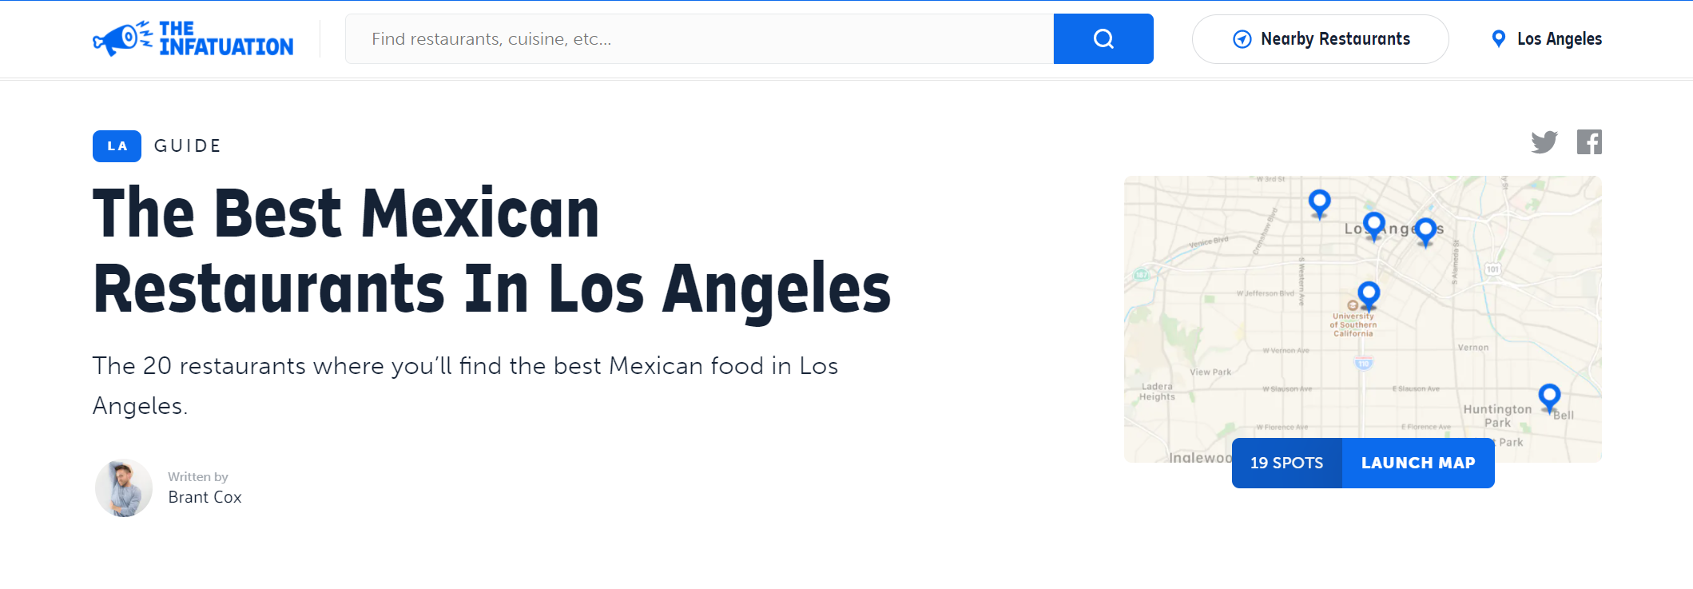

With the help of the Beautiful soup function, I took the most important data from this restaurant that were:

1. Restaurant Name
2. Food Type
3. Address

After gathering all the info, I created a data frame.

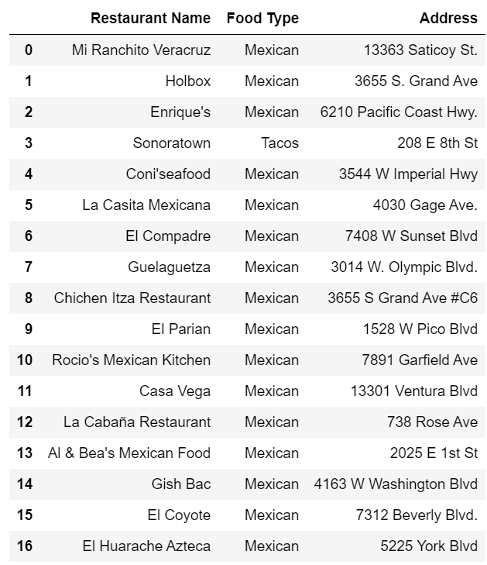

Subsequently I used an API to find the geographic position of each restaurant with the Latitude & Longitude coordinates and append it to the main data frame.

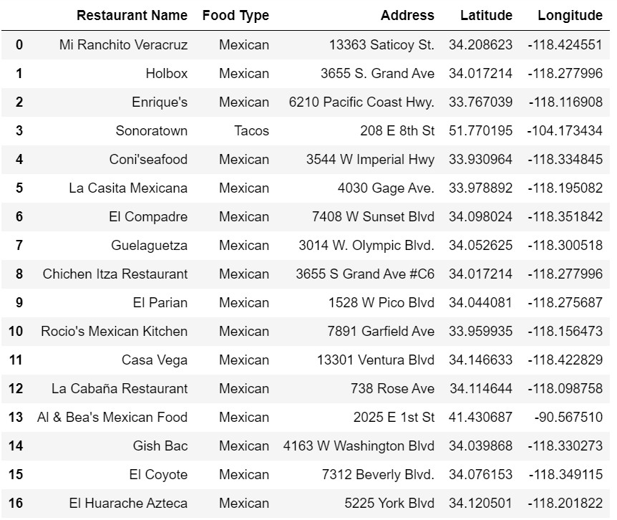

The Foursquare Api was used for looking up the nearby venues of the restaurants, just to ensure all those locations are well placed.

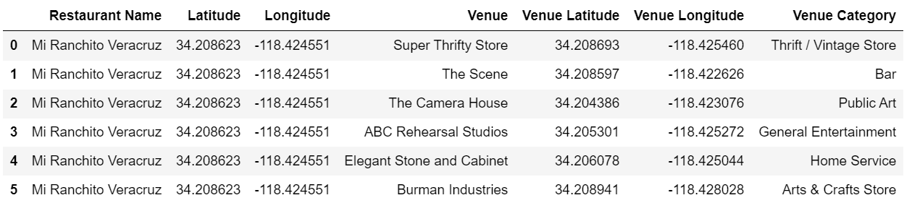

A map was created using the latitude and longitude of each location.

As we see, the popular Mexican restaurants are based in Downtown LA.

**Results section**

A map was created using the latitude and longitude of each restaurant.

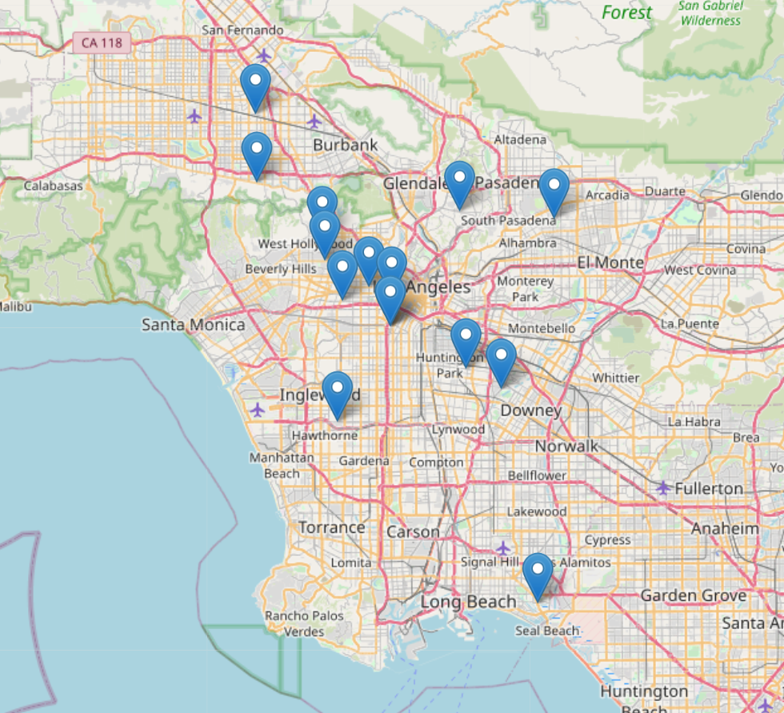

As we see, the popular Mexican restaurants are based in Downtown LA.

The proposal is to establish the new restaurant near the Santa Monica Beach due to the lack of Mexican food near the area.

**Discussion section**

The best choice for the new restaurant is Santa Monica beach, the only issue I had gathering info about this beach was that the Beautiful Soup didn’t work for the web page I needed.

The main Idea for the last part of the code was to gather the information of the best restaurants in Santa Monica from: <https://la.eater.com/maps/best-santa-monica-restaurants-los-angeles-map> and conclude that the top food from that area is not related to the Mexican food.

A good proposal would be to gather information about the most crowded beaches in Los Angeles and check if those areas have small Mexican food businesses nearby.

**Conclusion section**

After analyzing al the data, our Mexican restaurant should be established nearby the beach since there are no similar restaurants near that area. As we saw in the final part of our report, Santa Monica beach would be a perfect place due to the high amount of visitors this place has.